Exploring Computer Science Workshop Details
If you have any questions or concerns, please contact Karson at (801) 651-3431.
Dates/Times:
- Saturday, October 24, 2015
- 8:30 – 5:00
- The room will be open at 8 if groups need time to collaborate

Directions:
- The workshop will begin with breakfast in the HOWA conference room. This room is in the same building as the cafeteria (the Shaw Student Center). The rest of the workshop will be held in room 354 of the Eccles Health, Wellness and Athletic Center (HWAC) at Westminster College - 1840 S 1300 E, Salt Lake City, UT 84105.
- From I-80 take exit 126 for 1300 East. Drive north on 1300 East until you turn left on 1700 south. Turn left onto 1200 East.
- Continue straight on 1200 East past the stop sign and you will reach the Dumke Parking Structure.
- From the parking lot, proceed up the stairs and follow the sidewalk forward. As you approach the commons, the building to your left will be the Shaw Student Center, where the workshop will commence. You can enter this building through the East doors.
Parking:
- The primary parking lot you will use is the Dumke Parking Structure.
- All parking is FREE for the weekend. Please disregard the signs that say otherwise.
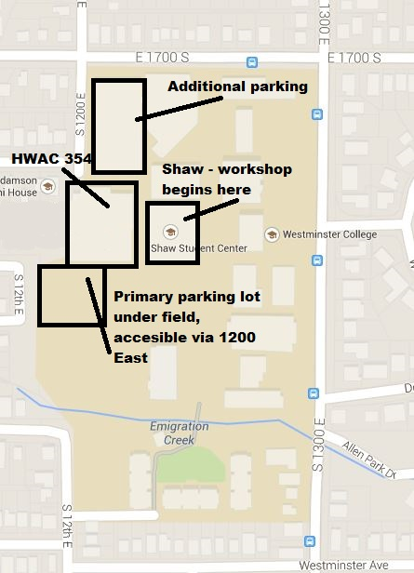

Food:
- Breakfast and lunch will be provided free of charge.
Is there anything else I should know?
- You are welcome to bring your personal laptop. If you do not bring a laptop, a computer will be provided for the duration of the workshop.
- Show up at 8 if you need to work with your group.
- Bring curriculum binder.

